CO- 2: AT – 2: Simulation Task

NAME : DEEVAGAR DHARSHAN K T
REG NO : 192512294

Question: Simulation of MIMO channel capacity under antenna number, SNR, bandwidth, fading model, and multiplexing order

Program

clc;
clear;
close all;

disp('Simulation of MIMO Channel Capacity');

%% Constants
BW = 100e6; % 100 MHz Bandwidth
SNR_dB = 0:2:30; % SNR Range
Nt = 2; % Number of Transmit Antennas
Nr = 2; % Number of Receive Antennas

%% ----------------------------------------------------
%% 1. Capacity vs SNR
%% ----------------------------------------------------
Capacity_SNR = zeros(size(SNR_dB));

for i = 1:length(SNR_dB)

snr = 10^(SNR_dB(i)/10);

H = (randn(Nr,Nt)+1j*randn(Nr,Nt))/sqrt(2);

Capacity_SNR(i) = BW*log2(det(eye(Nr)+(snr/Nt)*(H*H')));

end

figure
plot(SNR_dB,real(Capacity_SNR)/1e6,'b','LineWidth',2)
grid on
xlabel('SNR (dB)')
ylabel('Capacity (Mbps)')
title('MIMO Channel Capacity vs SNR')

%% ----------------------------------------------------
%% 2. Capacity vs Number of Antennas
%% ----------------------------------------------------
Antennas = 1:8;
Capacity_Antenna = zeros(size(Antennas));

snr = 10^(20/10);

for i=1:length(Antennas)

Nt = Antennas(i);
Nr = Antennas(i);

H = (randn(Nr,Nt)+1j*randn(Nr,Nt))/sqrt(2);

Capacity_Antenna(i)=BW*log2(det(eye(Nr)+(snr/Nt)*(H*H')));

end

figure
plot(Antennas,real(Capacity_Antenna)/1e6,'r-o','LineWidth',2)
grid on
xlabel('Number of Antennas (Tx = Rx)')
ylabel('Capacity (Mbps)')
title('Capacity vs Number of Antennas')

%% ----------------------------------------------------
%% 3. Capacity vs Bandwidth
%% ----------------------------------------------------
Bandwidth = [20 40 60 80 100]*1e6;
Capacity_BW = zeros(size(Bandwidth));

Nt=2;
Nr=2;
snr=10^(20/10);

H=(randn(Nr,Nt)+1j*randn(Nr,Nt))/sqrt(2);

for i=1:length(Bandwidth)

Capacity_BW(i)=Bandwidth(i)*log2(det(eye(Nr)+(snr/Nt)*(H*H')));

end

figure
plot(Bandwidth/1e6,real(Capacity_BW)/1e6,'k','LineWidth',2)
grid on
xlabel('Bandwidth (MHz)')
ylabel('Capacity (Mbps)')
title('Capacity vs Bandwidth')

%% ----------------------------------------------------
%% 4. Capacity under Different Fading Models
%% ----------------------------------------------------
Models={'Rayleigh','Rician','AWGN'};
Capacity_Fading=zeros(1,3);

Nt=2;
Nr=2;
snr=10^(20/10);

% Rayleigh
H=(randn(Nr,Nt)+1j*randn(Nr,Nt))/sqrt(2);
Capacity_Fading(1)=BW*log2(det(eye(Nr)+(snr/Nt)*(H*H')));

% Rician
K=5;
H=sqrt(K/(K+1))+sqrt(1/(K+1))*((randn(Nr,Nt)+1j*randn(Nr,Nt))/sqrt(2));
Capacity_Fading(2)=BW*log2(det(eye(Nr)+(snr/Nt)*(H*H')));

% AWGN
H=eye(2);
Capacity_Fading(3)=BW*log2(det(eye(Nr)+(snr/Nt)*(H*H')));

figure
bar(real(Capacity_Fading)/1e6)
grid on
set(gca,'XTickLabel',Models)
ylabel('Capacity (Mbps)')
title('Capacity under Different Fading Models')

%% ----------------------------------------------------
%% 5. Capacity vs Multiplexing Order
%% ----------------------------------------------------
Streams=1:4;
Capacity_Stream=zeros(size(Streams));

snr=10^(20/10);

for i=1:length(Streams)

Ns=Streams(i);

Nt=max(4,Ns);
Nr=max(4,Ns);

H=(randn(Nr,Nt)+1j*randn(Nr,Nt))/sqrt(2);

Capacity_Stream(i)=BW*log2(det(eye(Nr)+(snr/Nt)*(H*H')));

end

figure
plot(Streams,real(Capacity_Stream)/1e6,'m-s','LineWidth',2)
grid on
xlabel('Multiplexing Order')
ylabel('Capacity (Mbps)')
title('Capacity vs Multiplexing Order')

%% ----------------------------------------------------
%% 6. Combined Comparison for Different Antenna Configurations
%% ----------------------------------------------------
SNR_dB=0:2:30;

Config=[2 2;4 4;8 8];

figure

hold on

for c=1:3

Nt=Config(c,1);
Nr=Config(c,2);

Cap=zeros(size(SNR_dB));

for i=1:length(SNR_dB)

snr=10^(SNR_dB(i)/10);

H=(randn(Nr,Nt)+1j*randn(Nr,Nt))/sqrt(2);

Cap(i)=BW*log2(det(eye(Nr)+(snr/Nt)*(H*H')));

end

plot(SNR_dB,real(Cap)/1e6,'LineWidth',2)

end

grid on
xlabel('SNR (dB)')
ylabel('Capacity (Mbps)')
title('Comparison of Different MIMO Configurations')
legend('2x2','4x4','8x8','Location','northwest')

- MIMO Channel Capacity vs SNR

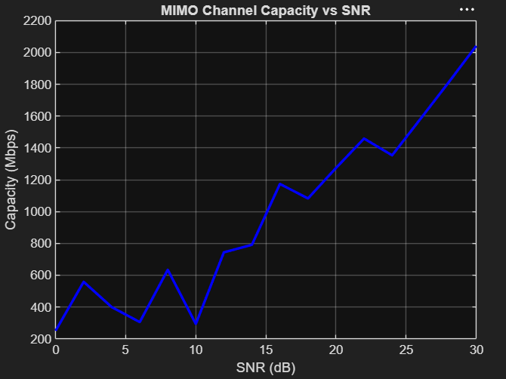

- Capacity vs Number of Antennas
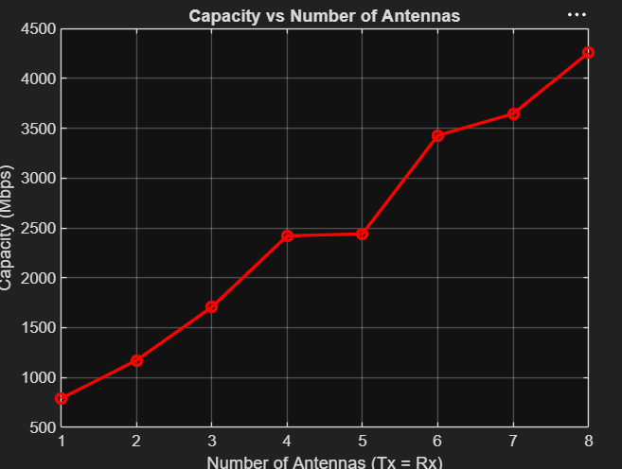

- Capacity vs Bandwidth

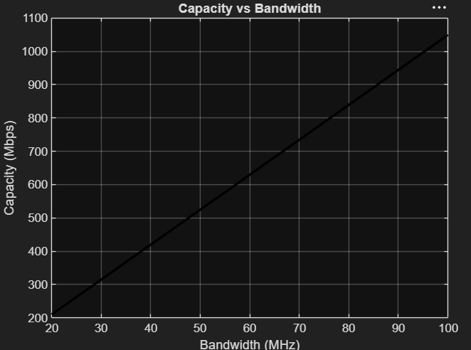
- Capacity under Different Fading Models

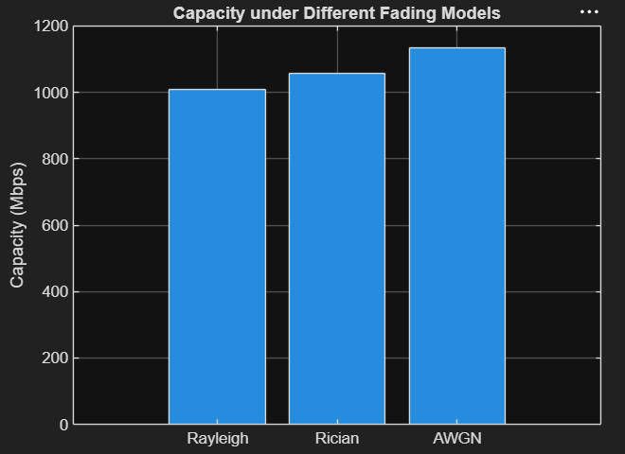

- Capacity vs Multiplexing Order

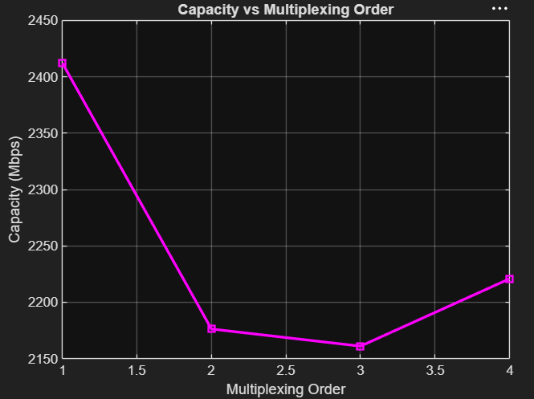
F. Comparison of Different MIMO Configurations

